Day 1 of Development:
Added:
- Create github and upload project planning files
- Gather requirements through Google Docs
- Create Use Case Diagram
- Create Class Diagram
- Create and apply Labels
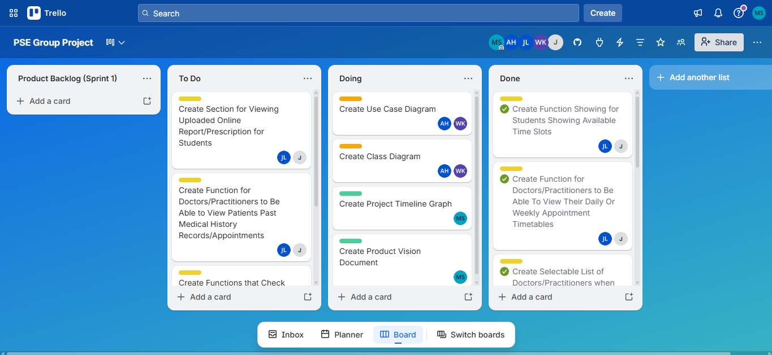
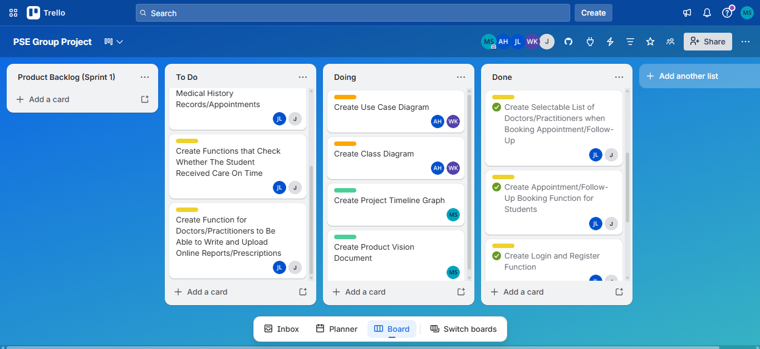

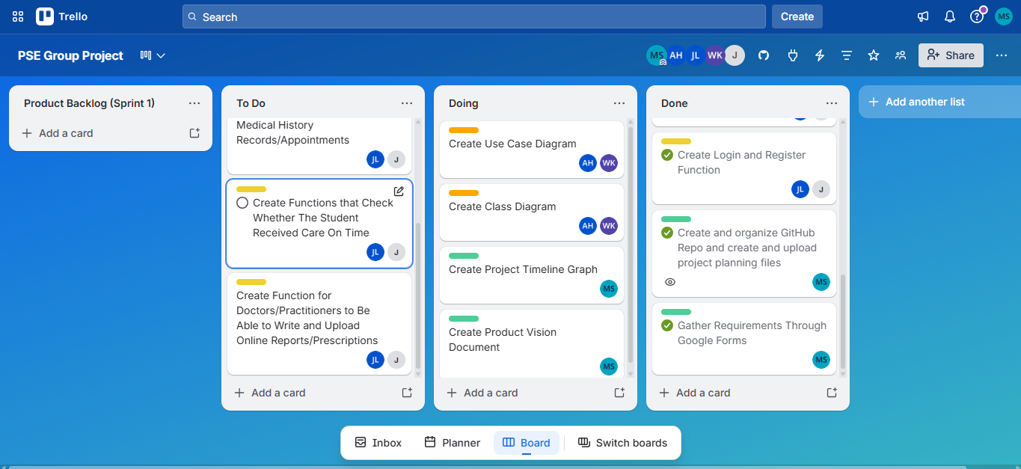

Day 2 of Development:
Added:
Moved:
- Create project timeline graph and product vision document from doing to done.
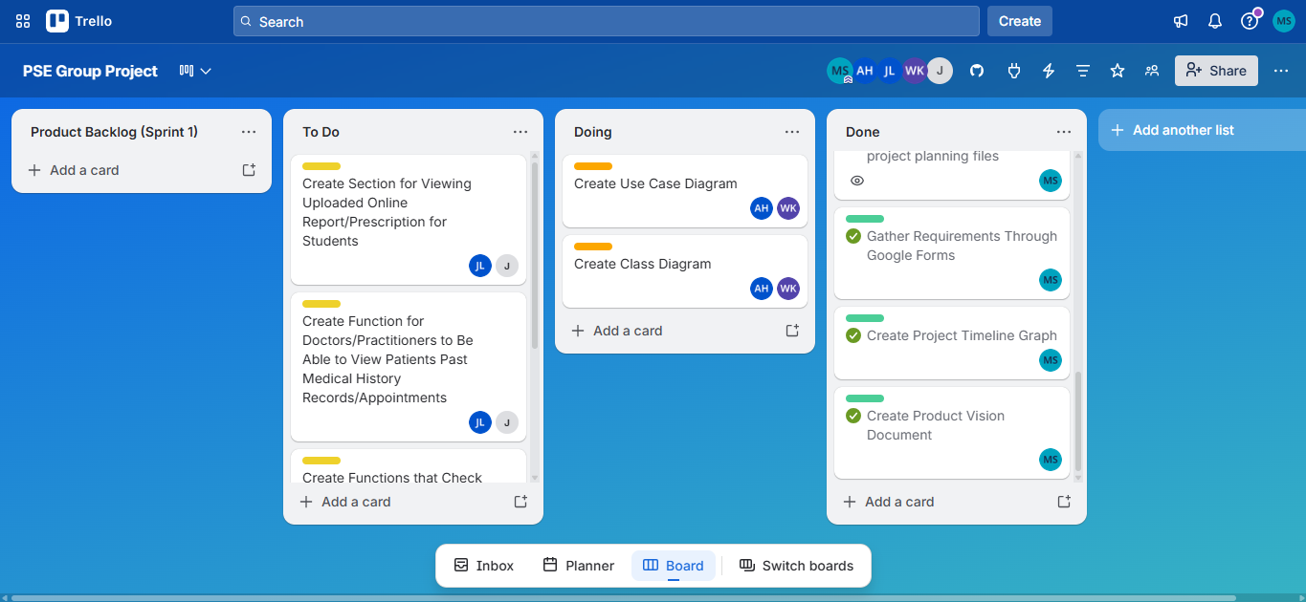

Day 3 of Development:
Added:
- Start Prototype Version 2 Creation
- Enhance Prototype UI/UX
- Add remaining features from last sprint to new prototype
Moved:
- Start Prototype Version 2 Creation to Done
- Enhance Prototype UI/UX to Doing
- Add remaining features from last sprint to new prototype to Doing
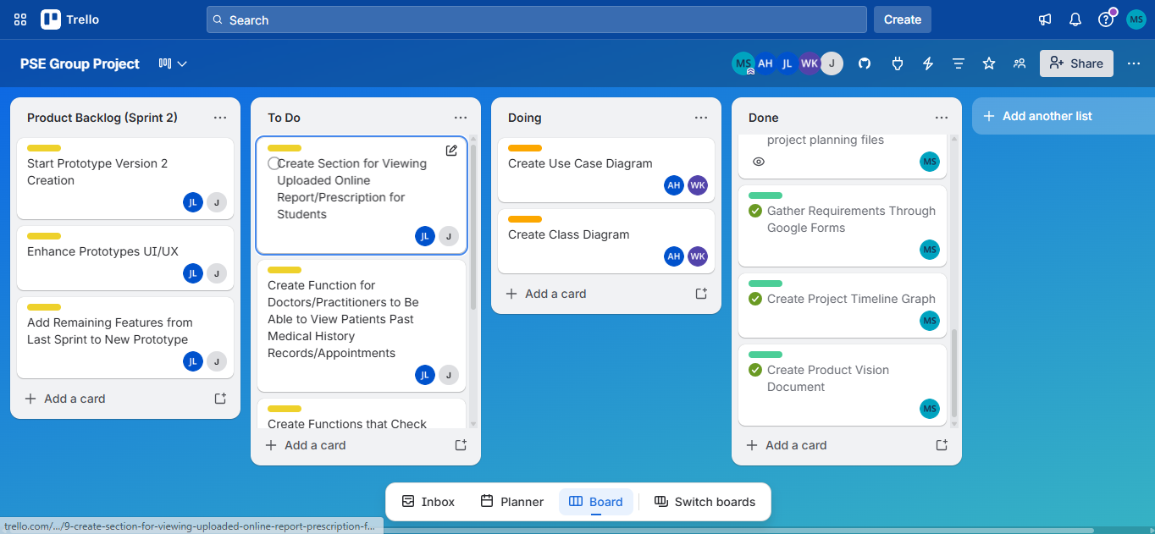
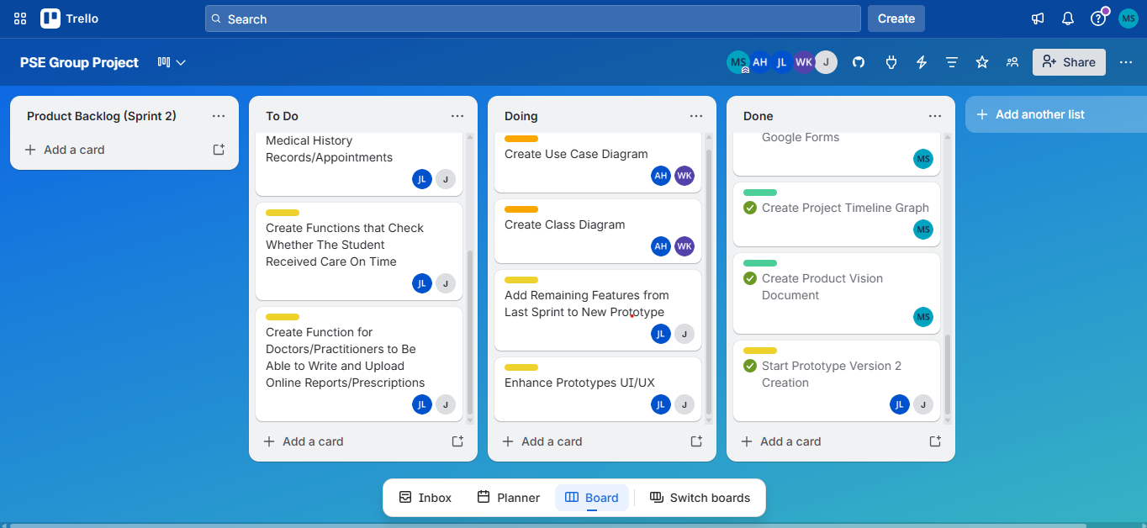
Day 4 of Development:
Added:
Moved:
- Create Use Case Diagram to Done
- Create Class Diagram to Done
- Create Section for Viewing Uploaded Online Report/Prescription for Students to Done
- Create Function for Doctors/Practitioners to Be Able to View Patients Past Medical History Records/Appointments to Done
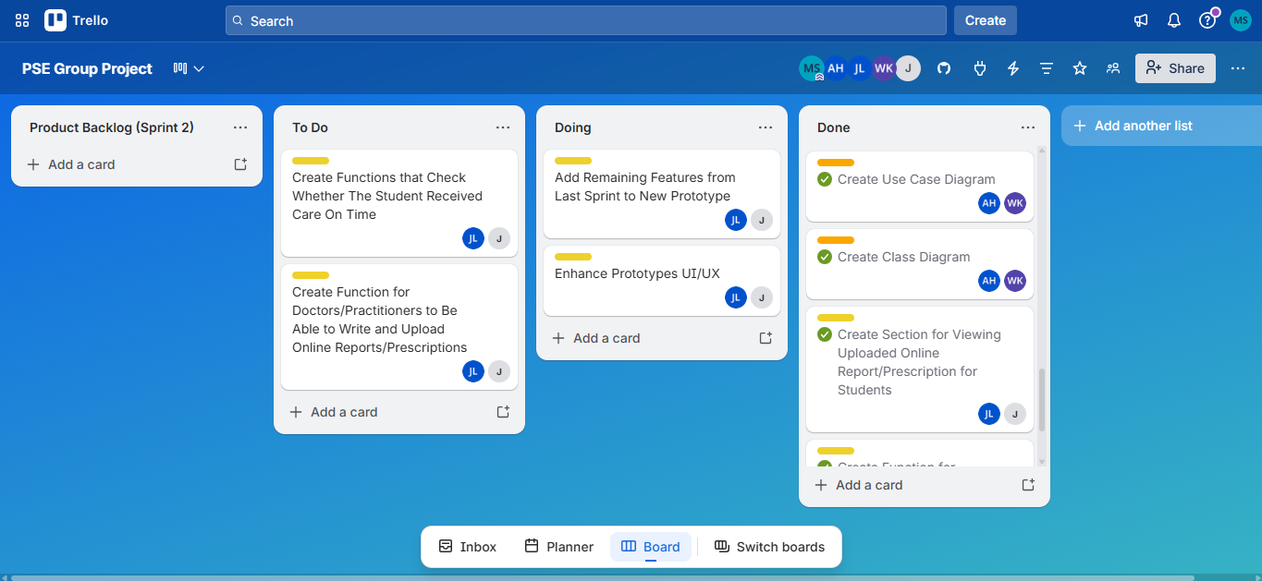
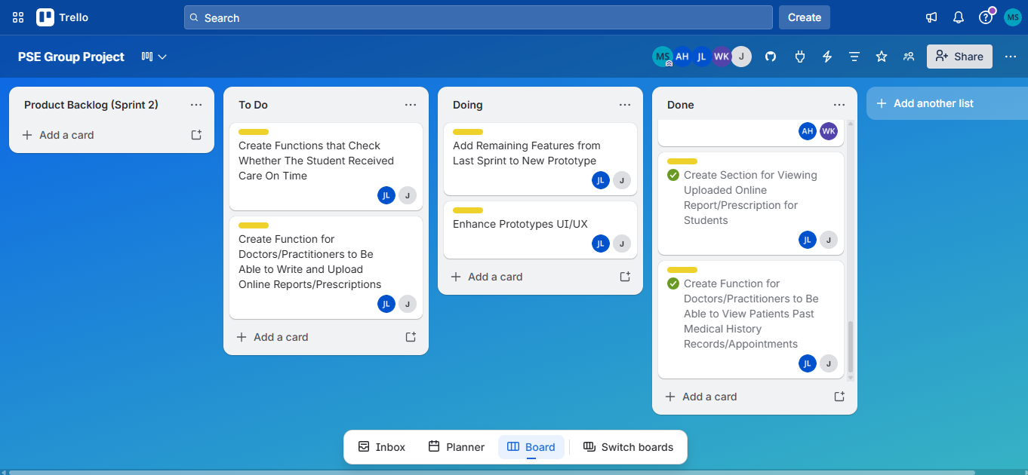
Day 5 of Development:
Added:
- Administration/Management section with medical leave Reviewing and Approving/Declining function
Moved:
- Administration/Management section with medical leave Reviewing and Approving/Declining function to Done
- Create Function for Doctors/Practitioners to Be Able to Write and Upload Online Reports/Prescriptions to Done
- Add Remaining Features from Last Sprint to New Prototype to Done
Removed:
- Create Functions that Check Whether The Student Received Care On Time
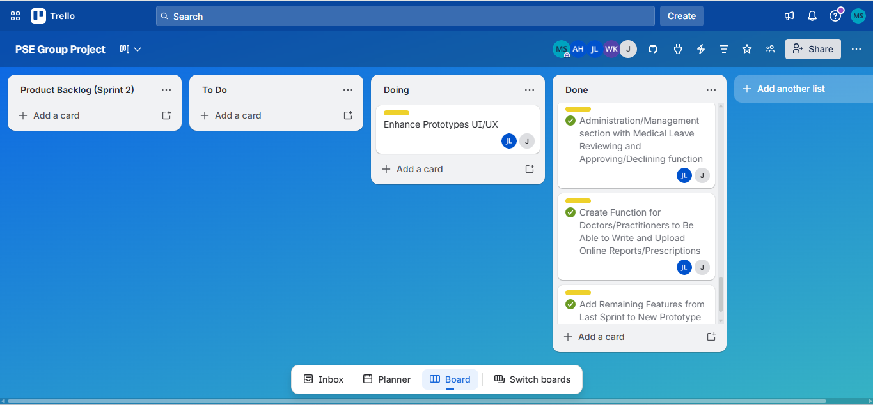

Day 6 of Development:
Moved:
- Enhance Prototype UI/UX to Done
